**VIT-AP UNIVERSITY, ANDHRA PRADESH**

**CSE3003 – Computer Networks - Lab Sheet: 8**

**Academic year:** 2023-2024  **Branch/ Class:** B.Tech

**Semester:** Fall  **Date:**

**Faculty Name:** Prof. S.Gopikrishnan  **School:** SCOPE

**Student name:Aman Sahu Reg. no.:22BCE7224**

**LAB 8**

1. Design and configure a network using OSPF Routing protocol.

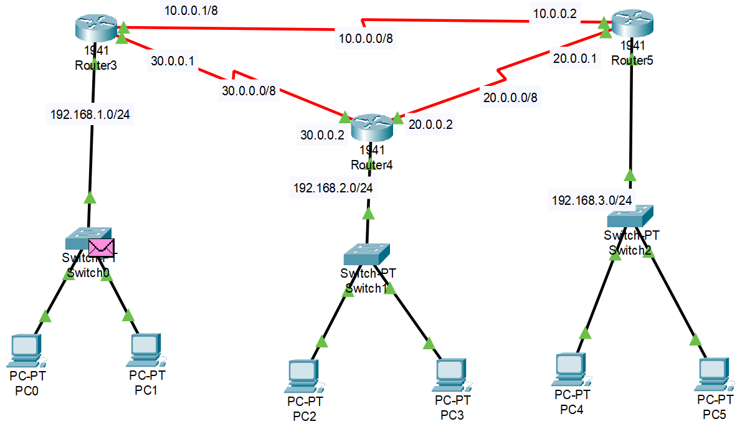

Objectives:

1. Design a network using seven routers and switches with one source and one destination PC
2. Configure all the routers with OSPF routing.
3. Verify the connectivity.

**Addressing Table:**

|  |  |  |  |  |
| --- | --- | --- | --- | --- |
| **Device** | **Area** | **IP Address** | **wild card bits** | **Subnet Mask** |
| PC1 | 0 | 192.168.1.5 |  | 255.255.255.0 |
| PC2 | 0 | 192.168.1.6 |  | 255.255.255.0 |
| PC3 | 0 | 192.168.2.5 |  | 255.255.255.0 |
| PC4 | 0 | 192.168.2.6 |  | 255.255.255.0 |
| PC5 | 0 | 192.168.3.5 |  | 255.255.255.0 |
| PC6 | 0 | 192.168.3.6 |  | 255.255.255.0 |
| Router 1 fa0/1 | 0 | 192.168.1.1 | 0.0.0.255 | 255.255.255.0 |
| Router 1 Serial 2/0 | 0 | 10.0.0.1 | 0.255.255.255 | 255.0.0.0 |
| Router 1 Serial 2/0 | 0 | 10.0.0.2 | 0.255.255.255 | 255.0.0.0 |
| Router 2 fa0/1 | 0 | 192.168.2.1 | 0.0.0.255 | 255.255.255.0 |
| Router 2 Serial 2/0 | 0 | 20.0.0.1 | 0.255.255.255 | 255.0.0.0 |
| Router 2 Serial 3/0 | 0 | 20.0.0.2 | 0.255.255.255 | 255.0.0.0 |
| Router 3 fa 0/1 | 0 | 192.168.3.1 | 0.0.0.255 | 255.255.255.0 |
| Router 3 Serial 2/0 | 0 | 30.0.0.1 | 0.255.255.255 | 255.0.0.0 |
| Router 3 Serial 2/0 | 0 | 30.0.0.2 | 0.255.255.255 | 255.0.0.0 |

Expected output screenshots:

* 1 success communication
* 7 router configuration screenshots

Sample output:

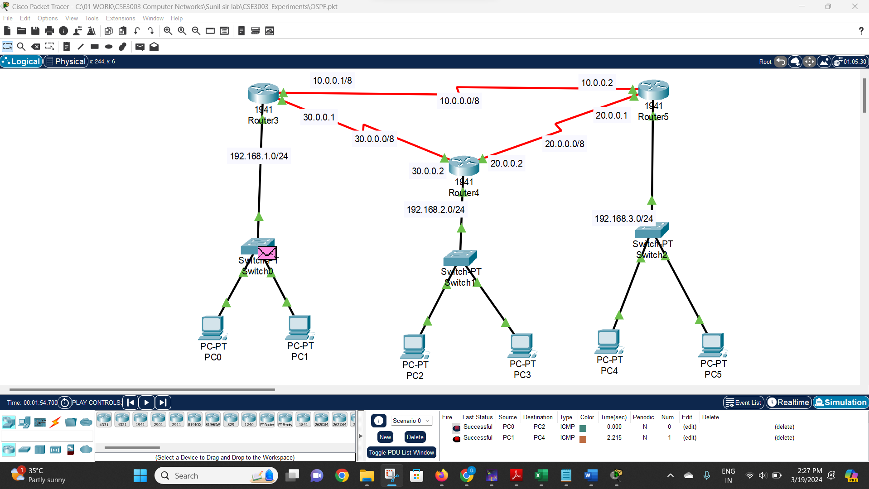

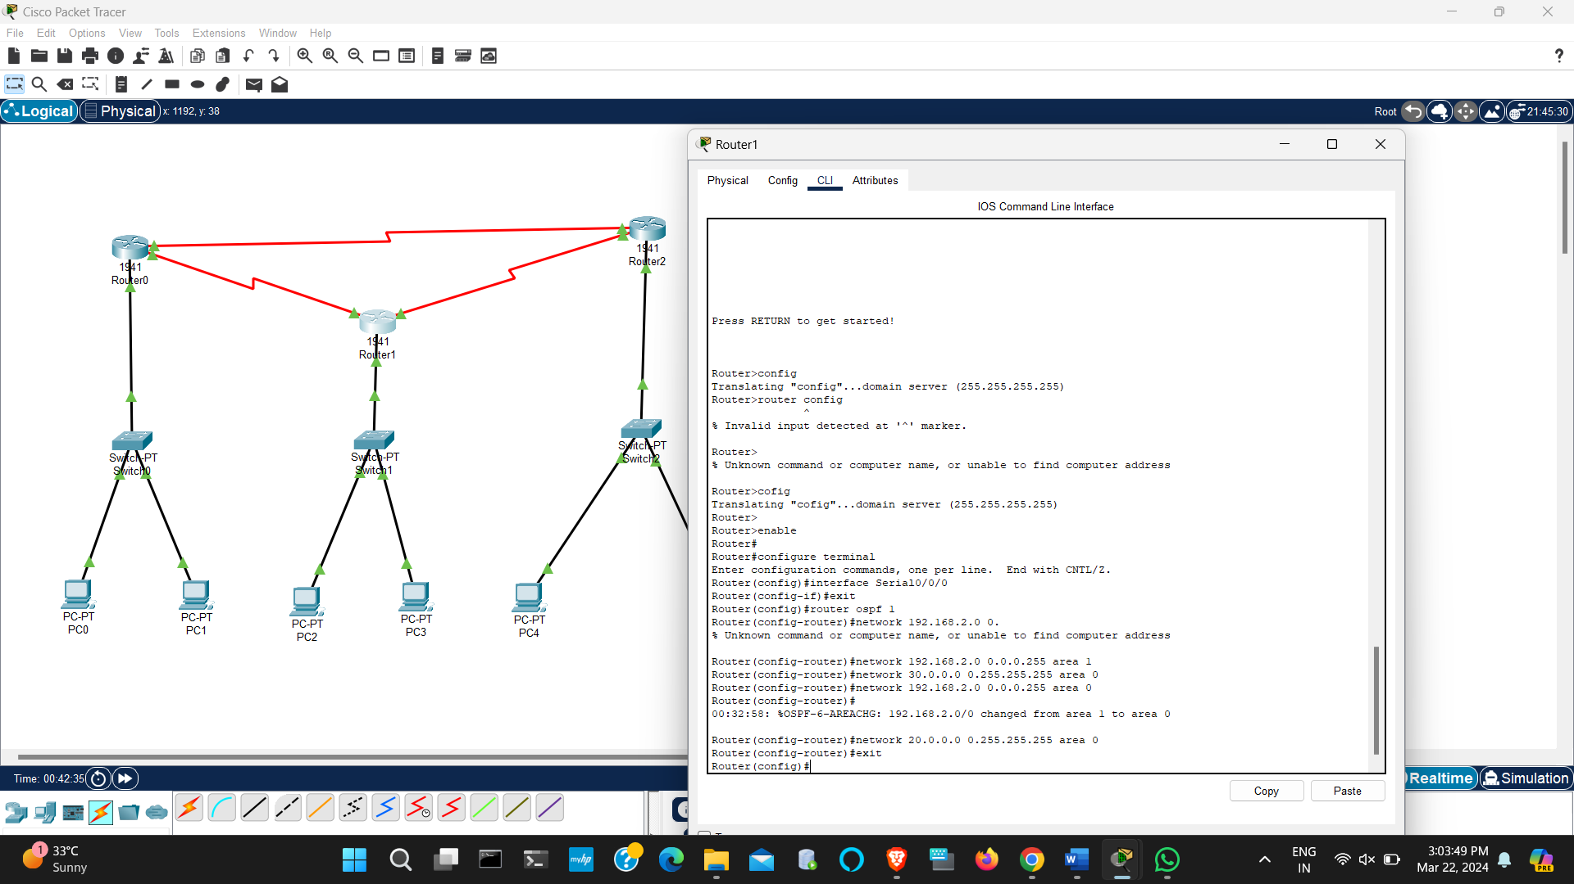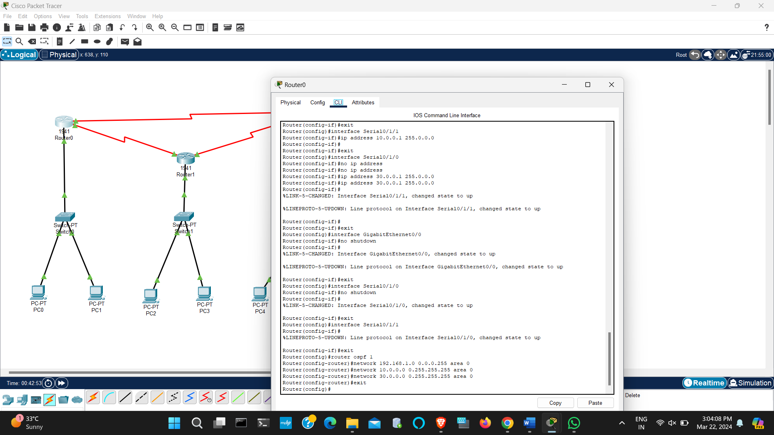

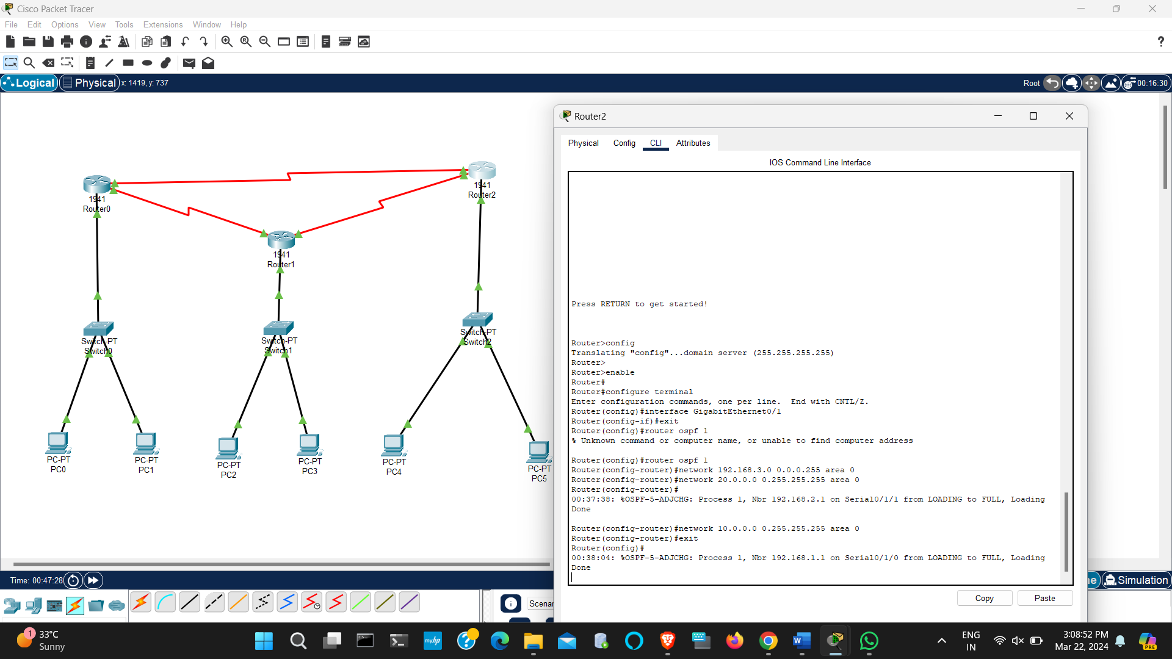

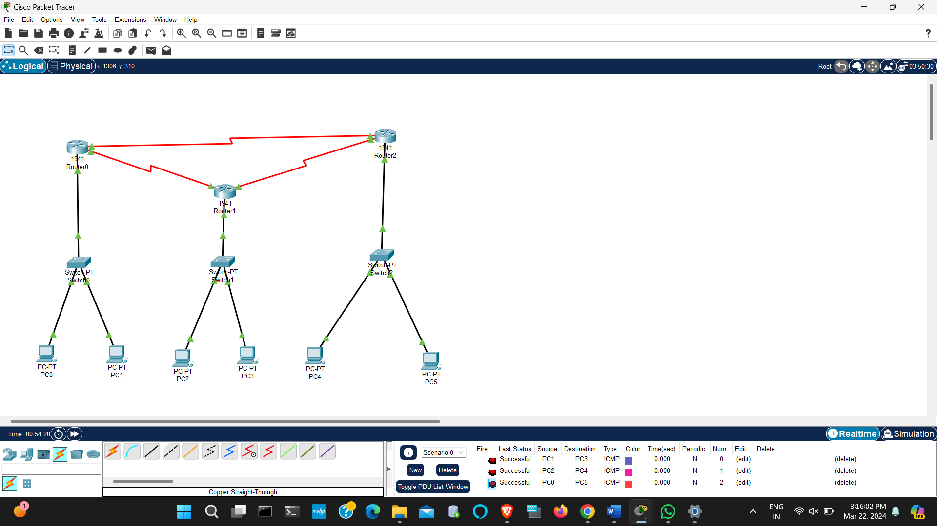

1. Design and configure the following network using OSPF Routing protocol.

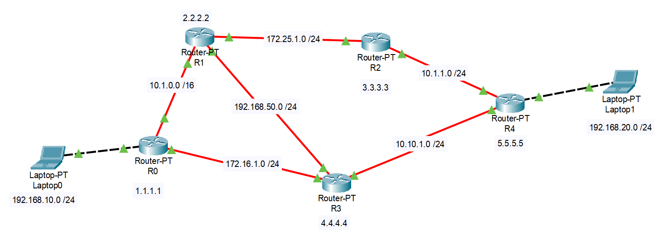

Expected output screenshots:

* 1 success communication from any to any
* 5 router configuration screenshots

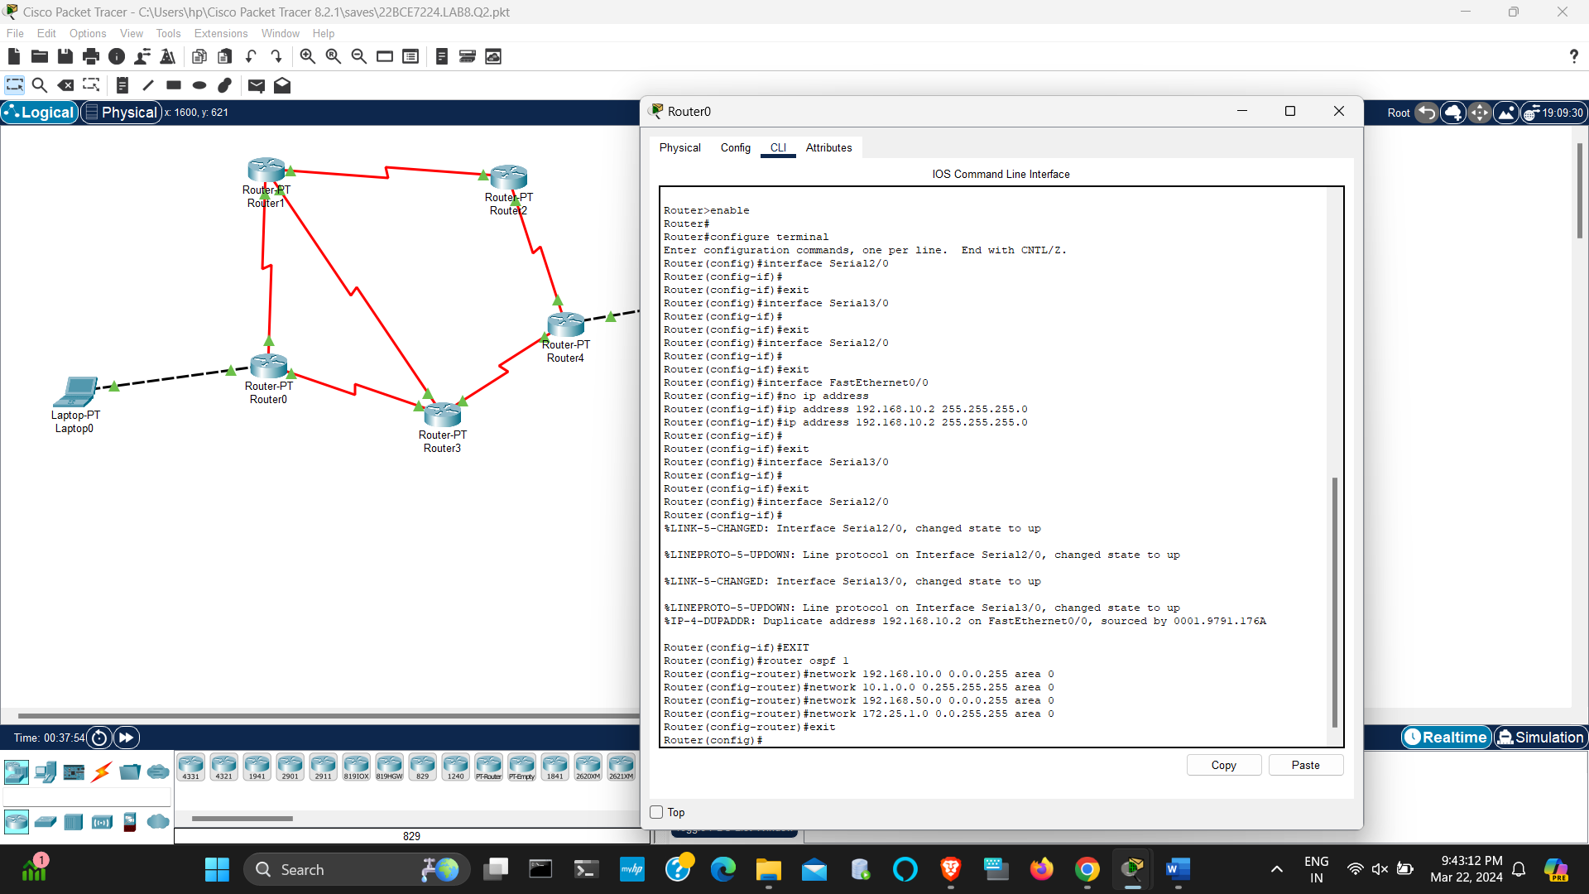

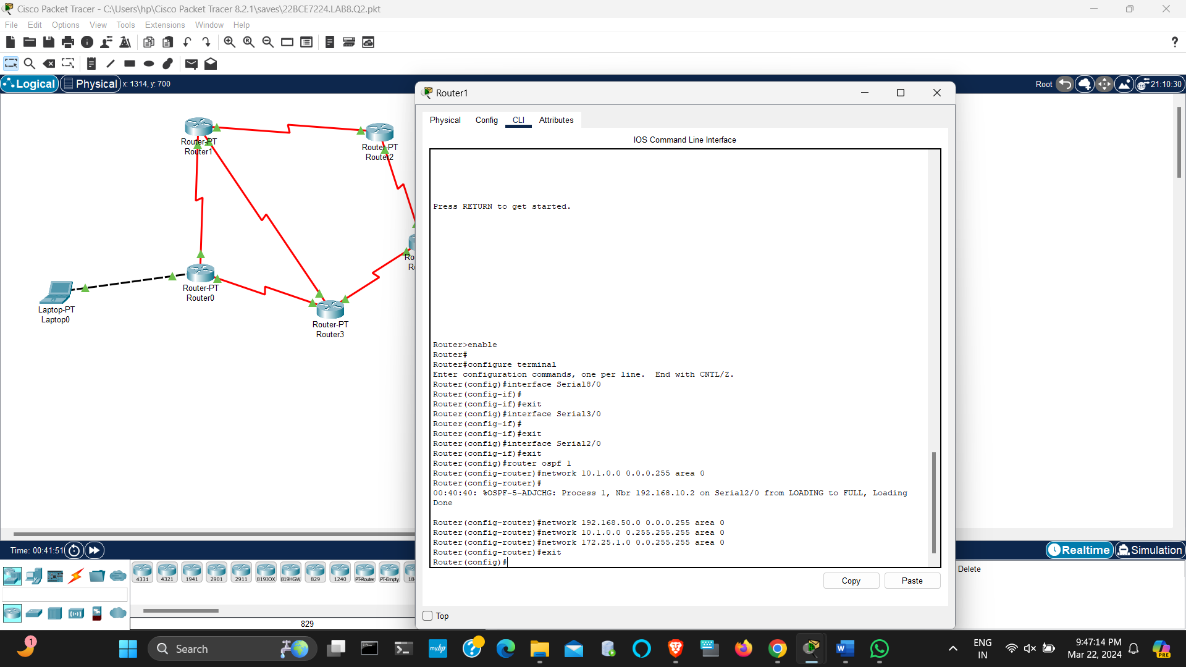

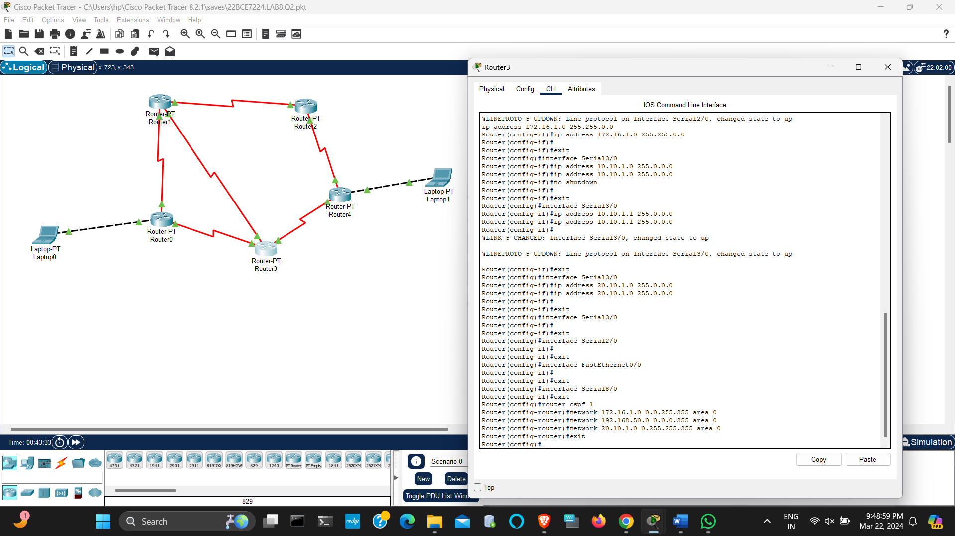

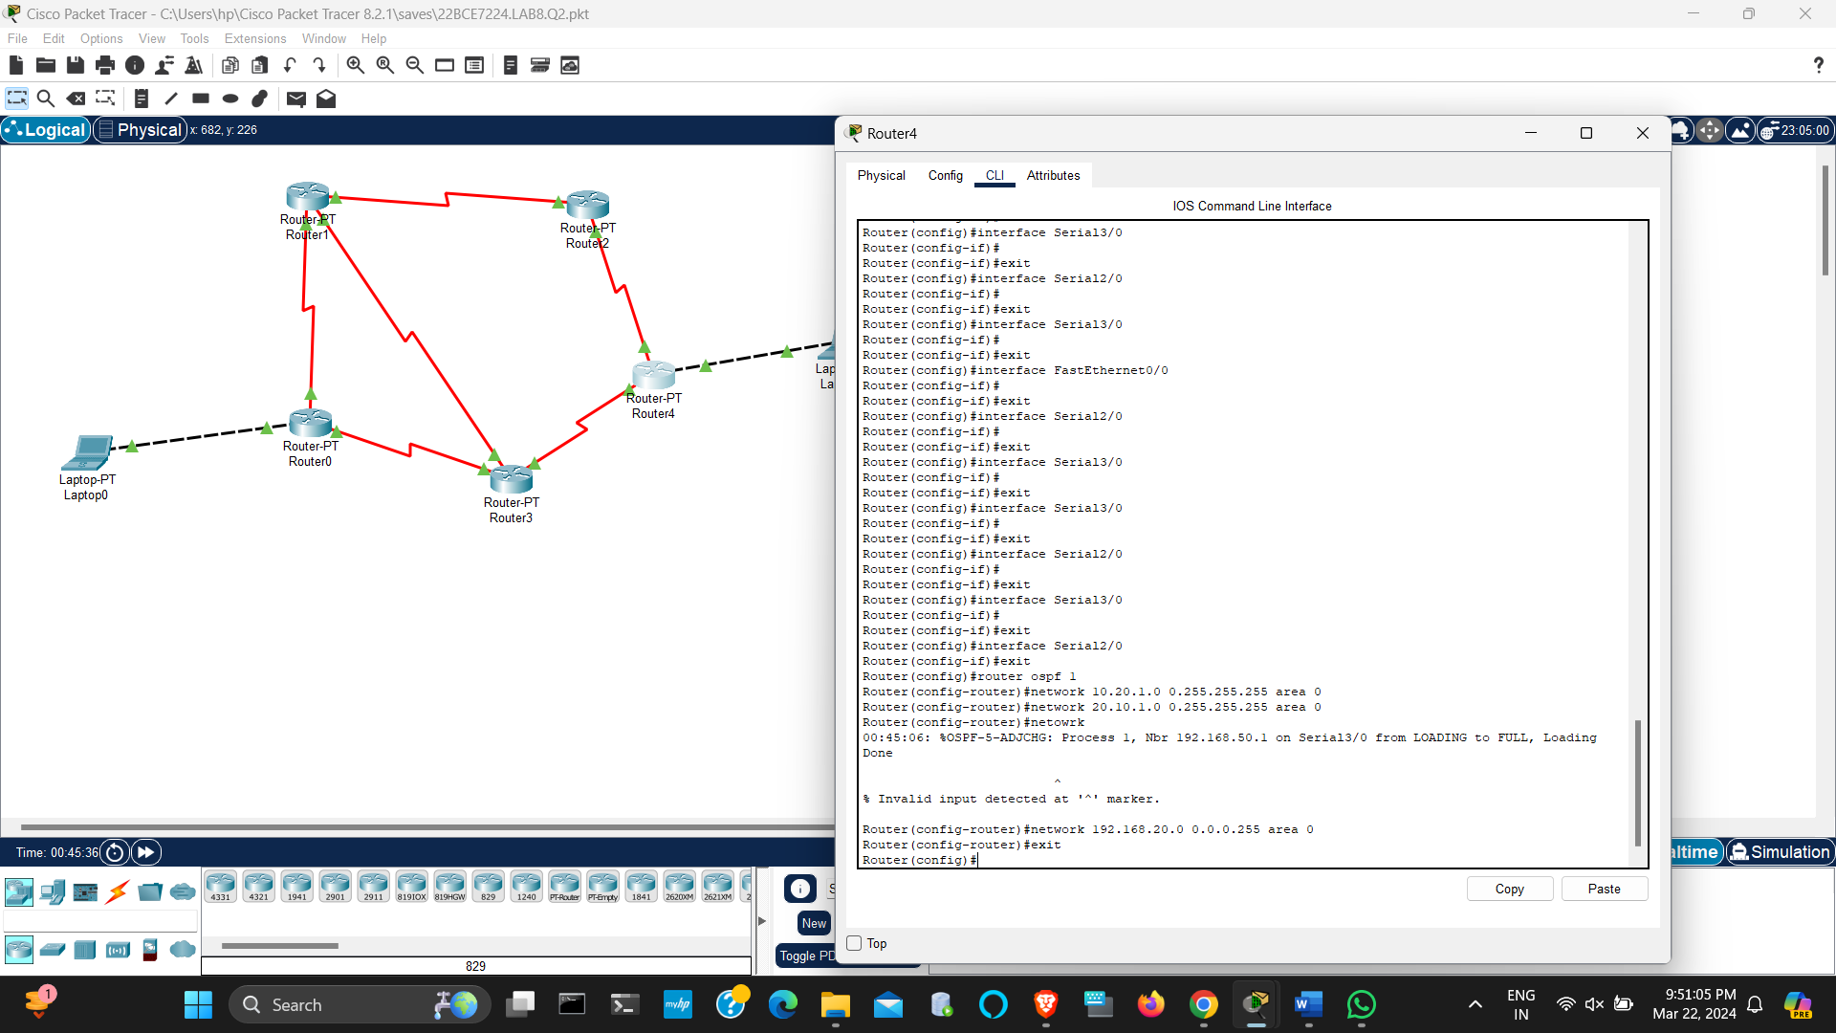

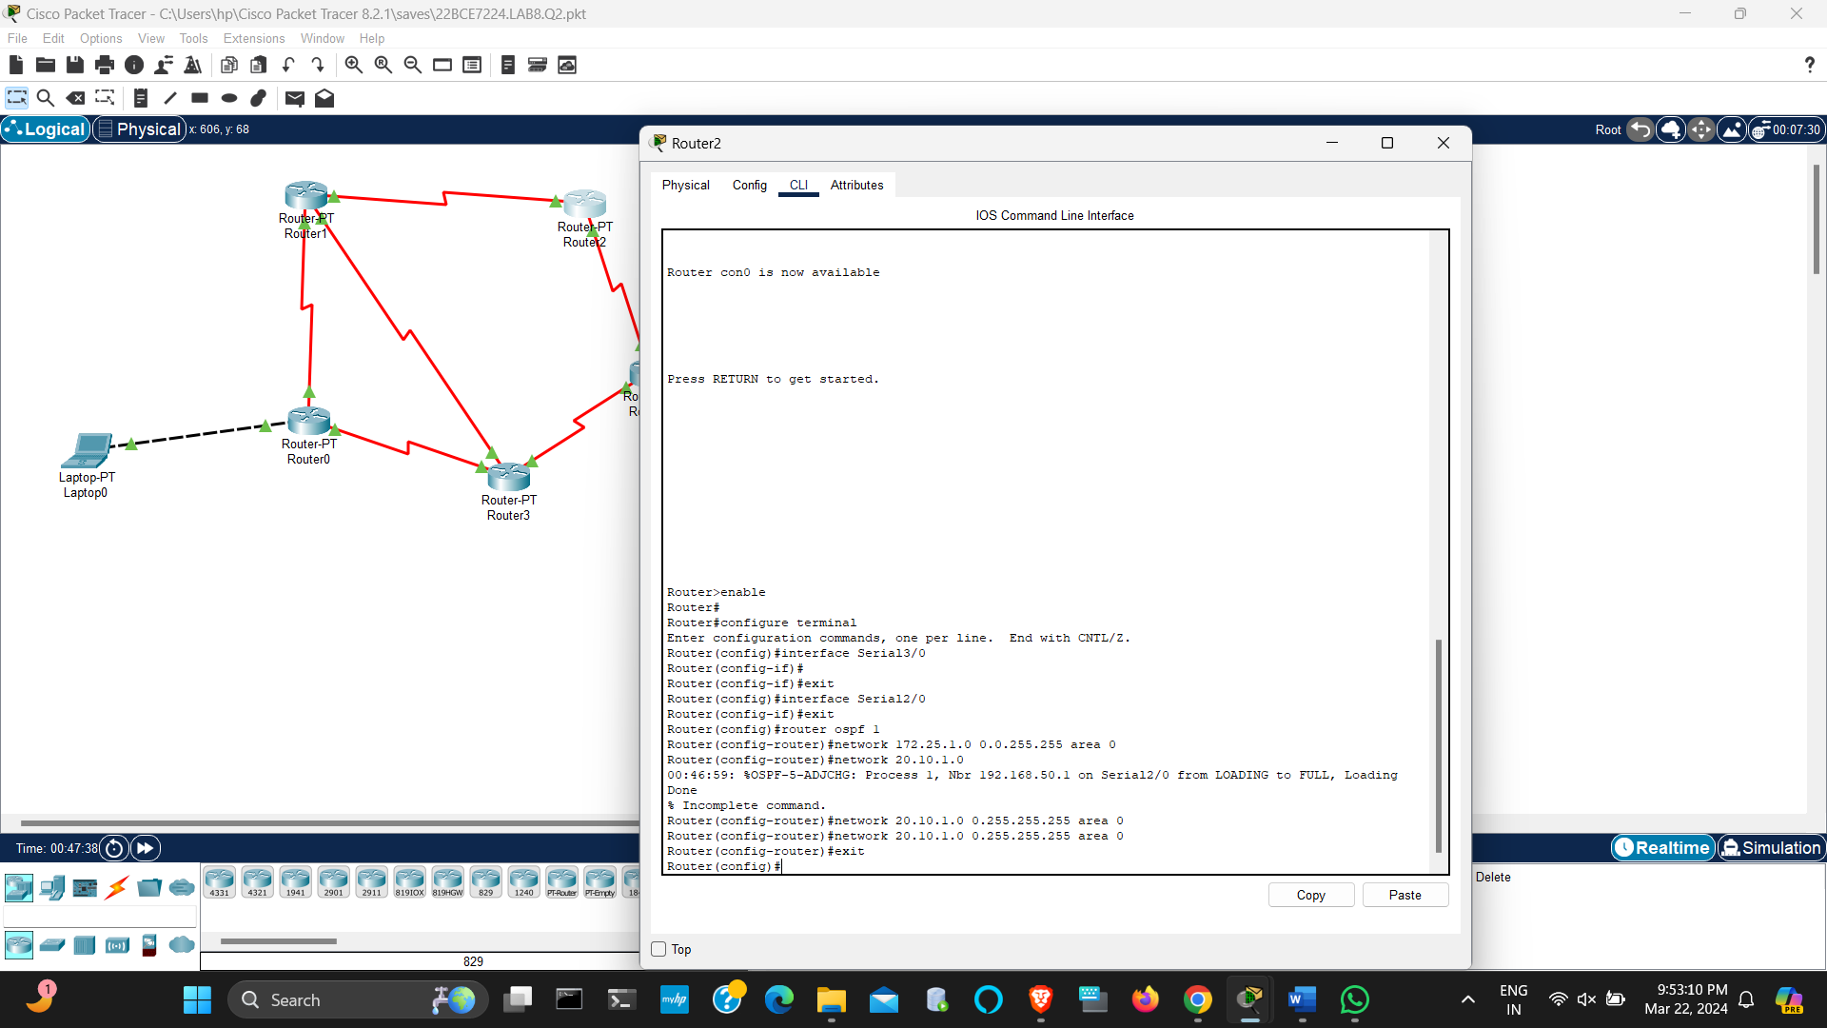

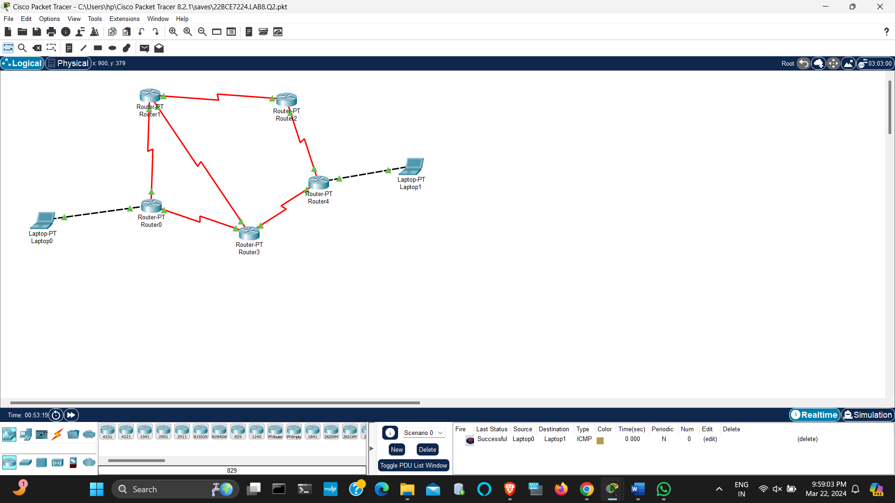

1. Design and configure the following network using OSPF Routing protocol.

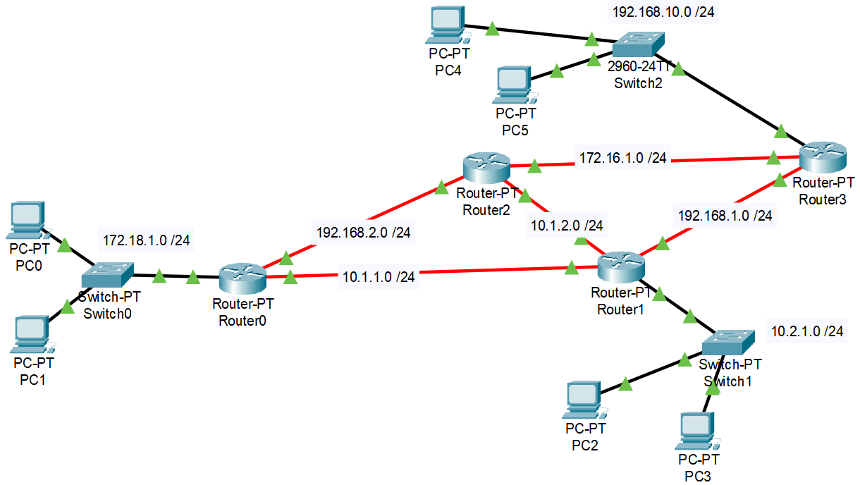

Expected output screenshots:

* 2 success communication from any to any
* 4 router configuration screenshots

